AEROSEM FDD featuring the new coulter rail
15 cm row spacing on seed drill with pressurised front hopper

The unique AEROSEM seed drill concept from Pöttinger teams up high output with versatility. Perfect placement of the seed is always the most important factor, and on this machine it is guaranteed by a precision universal metering system and ingenious DUAL DISC coulters. The front hopper also offers the capability of sowing two different components together at the same time.

The AEROSEM FDD seed drill with front hopper
The coulter rail on the AEROSEM FDD has been adapted to coincide with the facelift of the LION V folding power harrows.
Pöttinger, the arable farming professional, is expanding its range of pneumatic implement-mounted seed drills with the AEROSEM FDD front hopper model available with working widths of 5.0 and 6.0 m. This means that row spacings of 12.5 or 15.5 cm are possible over a working width of 5.0 m in combination with the medium weight LION V 5040, 15.0 cm over a working width of 6.0 m with the medium weight LION V 6040, and 12.5 cm with the heavy duty LION V MASTER.

Combining the highest performance with operating convenience and versatility.
Combining the AEROSEM FDD with the LION V power harrow series delivers high output for a versatile range of applications. Special attention has been paid to a compact design, and the result is a neatly organised machine with an improved overview and optimised weight distribution. In addition to a dual metering system and the IDS distribution head, the seed drill's versatility is further increased by being able to attach and remove the coulter rail quickly.

Adapted to meet flexible requirements
The simultaneous application of several seed and fertiliser components during drilling has become increasingly standard in recent years. The main focus is on providing plants with nutrients from the germination stage onwards.
Due to an increase in metering flow rates, a long conveying path from the front of the tractor and higher driving speeds, it is now become necessary to change to a pressurised system for the front hopper. This system meets the new seed drill technology requirements, so larger quantities of seed material or fertiliser can be conveyed over longer distances.
The range of hopper volumes offered and the choice between one or two metering systems meet every requirement in the field.
Photo preview:
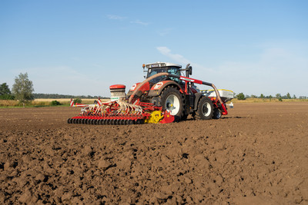 | 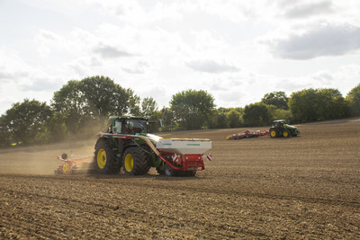
AEROSEM 5002 FDD combines high output with operating convenience | Flexible operations with the AEROSEM 5002 FDD
https://www.poettinger.at/de_at/newsroom/pressebild/41245 | https://www.poettinger.at/de_at/newsroom/pressebild/41220

More printer-optimised photos: www.poettinger.at/presse

